Data Flow Diagram


Date |   28 June 2026
Team ID | xxxxxx
Project Name | CreduCard Approval Prediction
Maximum Marks | 2 Marks

Data Flow Diagram
Create a Data Flow Diagram (DFD) to show how data moves through your system - between external entities, processes, and data stores. Use the symbol legend below as a guide.

DFD Symbol Legend

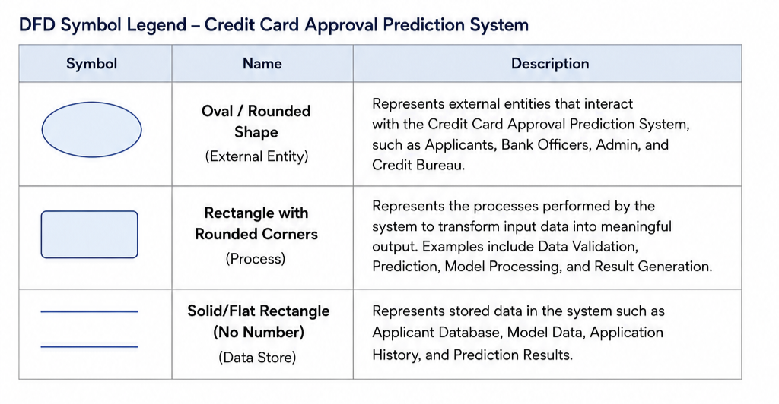

Example
The diagram below illustrates how the symbols above come together to form a complete data flow diagram.


